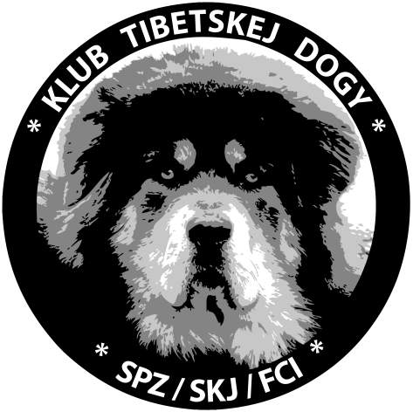
Klub tibetskej dogy (SPZ/SKJ/FCI)

Special show for Do Khyi/Tibetan Mastiff

6th October 2013

Spolocensky dom Vinicne

Judge: Mrs. Uschi Eisner (Austria)

Place: Spoločenský dom (Social House) Viničné, Cintorínska 11, 900 23 Viničné (nearby town Pezinok, about 30 km from Bratislava)

Titles: CAJC, CAC, Special show winner 2013, Special show young winner 2013, BOB

Deadline of entries: 2nd September 2013

Program:

      - registration
9.30 show opening
9.35-14.00 judging
14.00 final competitions

Entry fee:

Club member:
- for the first dog with catalogue 17 €
- for the next dog in youth, intermediate, open and in winner class 15 €
- for the dog in baby, puppy, honour and veteran class 10 €
- competitions 7 €

Non club member:
- for the first dog with catalogue 28 €
- for the next dog in youth, intermediate, open and in winner class 26 €
- for the dog in baby, puppy, honour and veteran class 15 €
- cmpetitions 10 €

Bank account details for payment (please keep and take confirmation about payment with you to show):
Account name: Klub tibetskej dogy
Club adress: Dolné Orešany 156, 919 02 Dolné Orešany
Bank account/bank code 633605018/0900
SWIFT CODE: GIBASKBX
IBAN: SK4609000000000633605018
Bank´s name: Slovenská sporiteľňa, a.s.
Bank´s adress: Tomášikova 48, 832 37 Bratislava, Slovak republic

Please, filled entry form, reservation form, copy of payment confirmation and copy of dog´s pedigree send to:
e-mail adress : klubdokhyi@gmail.com
or by post to adress: Martina Hudcovicová, Vaďovce 177, Kostolné 91613, Slovak Republic

The acceptance of entry form will be confirmed by e-mail, if you will not receive the acceptance, please, write us e-mail to adress: klubdokhyi@gmail.com For informations please call 00421 905595696.

Accomodation: Pension Galbov mlyn – www.galbovmlyn , Pension Rustica Garni – www.ssm.sk, Hotel Tilia – www.hoteltilia.sk, Pension Karolína - www.penzion-karolina.sk, Pension Grobský dvor - www.grobskydvor.sk, Pension pod Kláštorom - penzion@penzionpezinok.sk, Pension77 -www.penzion77.sk, Pension Fiori - fiori@pensionfiori.sk,...

General regulations

The show is accessible to males and females of all breeds registered in FCI-recognized studbooks, which reach the age required for the entry into the class on the show day.
The judging in the show is conducted in accordance with the FCI and SKJ show regulations. Titles Special show winner and Special show young winner can be consigned only to males/females which are owned by member of Klub tibetskej dogy.
During the show, the owners ensure that there are no injuries of dogs or persons. Free running of the dogs within the show grounds is forbidden.
The organizer of the show is not responsible for any damage caused by a dog or an exhibitor, nor for a death or a loss of a dog.
Non-participation on the show whatever the reason does not lay ground for reimbursement of the entry fee.
The sale of the puppies within the show grounds is forbidden.
By submitting the application form, the exhibitor agrees with publishing of his address in the show catalogue.
By submitting the application form, the exhibitor bindingly accepts all the FCI show regulations, the SKJ show regulations, the rules and regulations stated in this leaflet, and the instructions of the show committee.
Dogs being not included in catalogue will not be judged at the show.

Veterinary Regulations:
1. All dogs participating at the show must be clinically healthy.
2. The dogs must have antirabic vaccination and vaccination against canina distemper, parvovirosis not less than 21 days and not more that 12 months before the show.
3. Dogs must have a valid Pet Passport.

Complaints:
A complaint against the decision of a judge is not admissible. A complaint can be lodged solely for formal reasons of breach of show regulations and propositions. The complaint must be submitted in writing, together with lodging the deposit of 35 €, before the end of the show. If the complaint is found to be unjustified, this deposit will be handed over to the organiser.

